

Lab 12
Text Processing Using Strings

https://github.com/mmujtaba25/cs-110

Muhammad Mujtaba
CMD ID: 540040
mmujtaba.bese25seecs@seecs.edu.pk

  - Class: BESE 16B
  - Batch: 2k25

Task 1 [CLO 2]

CODE:
#include <iostream>
#include <string.h>

int main()
{
std::string first_city = "";
std::string second_city = "";
std::string third_city = "";

std::cout << "Enter first city name: ";
std::getline(std::cin, first_city);
std::cout << "Enter second city name: ";
std::getline(std::cin, second_city);
std::cout << "Enter third city name: ";
std::getline(std::cin, third_city);

// compare first and second
if (second_city < first_city)
std::swap(first_city, second_city);

// compare first and third
if (third_city < first_city)
std::swap(first_city, third_city);

// compare second and third
if (third_city < second_city)
std::swap(second_city, third_city);

std::cout << "Cities in alphabetical order: ";
std::cout << first_city << " - ";
std::cout << second_city << " - ";
std::cout << third_city << "\n";

return 0;
}

OUTPUT:
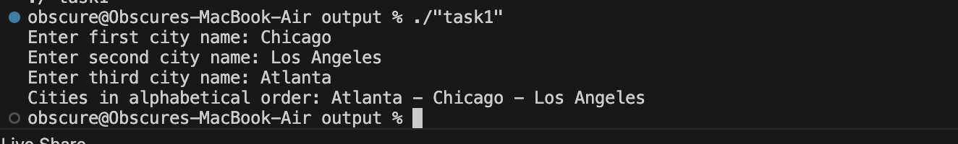

Task 2 [CLO 3]

CODE:
#include <iostream>
#include <cstring>

constexpr size_t ISBN_STR_SIZE = 13;

int getChecksum(const char s[ISBN_STR_SIZE - 1]);

int main()
{
// testing with example values
char testValues[][ISBN_STR_SIZE] = {
"978030640615", // 7
"978014028657", // 1
"978160234061" // 9
// values tested from https://freeisbn.com/check-digit/
};

for (auto &arr : testValues)
{
int checksum = getChecksum(arr);

std::cout << "The ISBN-13 number is: ";
for (size_t i = 0; i < ISBN_STR_SIZE - 1; ++i)
std::cout << arr[i];

std::cout << checksum << "\n";
}

char isbn[ISBN_STR_SIZE]; // 12 + null digit
std::cout << "Enter first 12 digits of ISBN: ";
std::cin >> isbn;

int checksum = getChecksum(isbn);
std::cout << "The ISBN-13 number is: " << isbn << checksum << "\n";

return 0;
}

int getChecksum(const char s[ISBN_STR_SIZE - 1])
{
// works because of ascii values ordering
// '0' translates to ascii value of 0
int d1 = s[0] - '0';
int d2 = s[1] - '0';
int d3 = s[2] - '0';
int d4 = s[3] - '0';
int d5 = s[4] - '0';
int d6 = s[5] - '0';
int d7 = s[6] - '0';
int d8 = s[7] - '0';
int d9 = s[8] - '0';
int d10 = s[9] - '0';
int d11 = s[10] - '0';
int d12 = s[11] - '0';

// applying formula
int checksum = 10 - ((d1 + 3 * d2 + d3 + 3 * d4 + d5 + 3 * d6 + d7 + 3 * d8 + d9 + 3 * d10 + d11 + 3 * d12) % 10);

// return 0 if 10
return (checksum == 10) ? 0 : checksum;
}

OUTPUT:
